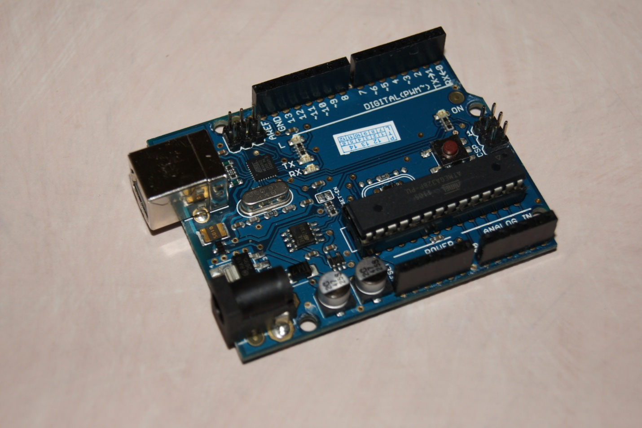

**The Arduino Uno Microcontroller PCB.**

This board is available on eBay for about $20. If you buy this online, you will have to install the software as described in the Instructions – readme.txt file

This involves downloading the Arduino design package from [www.arduino.cc](http://www.arduino.cc)

Because I buy them in lots, I can offer them already programmed and tested for less than the typical purchase price. Right now I can go $15 programmed + shipping. (USB interface cable included)

If you already have an Arduino UNO board, and can program it yourself, see the options on the next page.

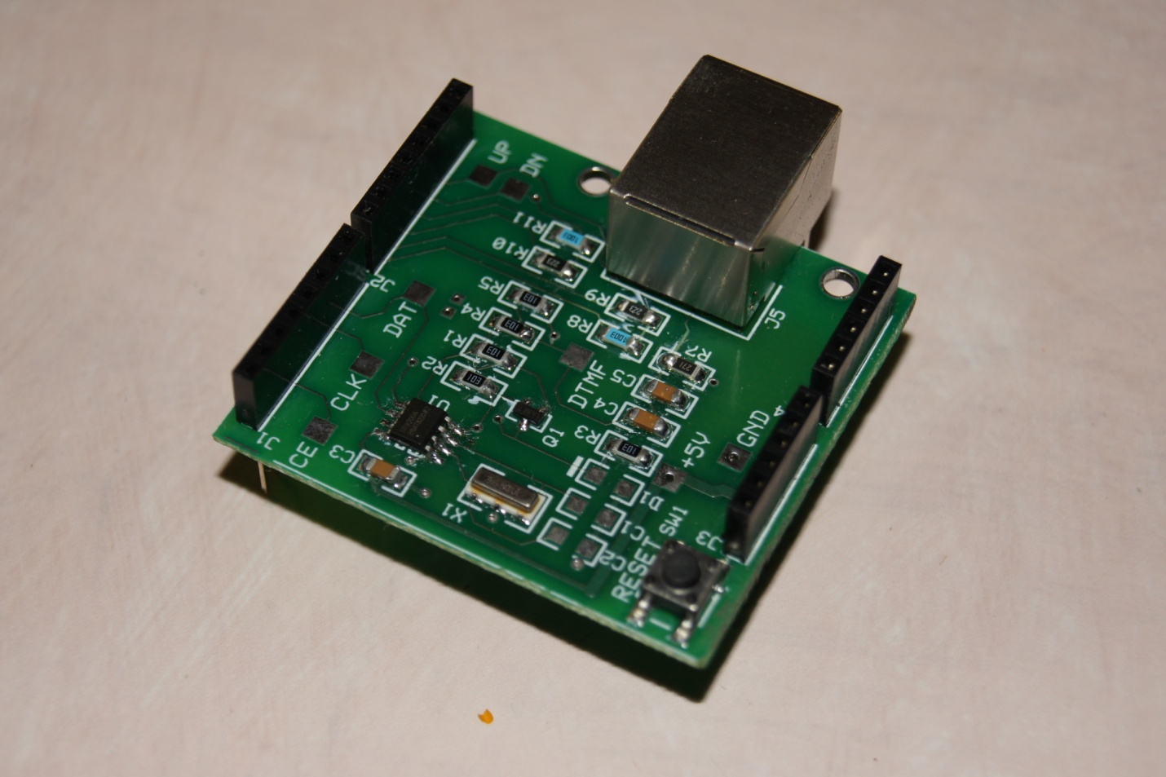

**The DTMF Shield Board (Generates DTMF tones and switch closures to emulate the microphone.**

This is the custom board we designed that is controlled by the Arduino UNO.

If you already have an Arduino UNO board, and can program it yourself, see options below.

Assembling and soldering surface mount components is a bit tedious, so we offer this board assembled and tested. At present, I have ordered quantities of 50, allowing me to offer the board assembled and tested for $28 + shipping . (CAT5e patch cable included on options 2 & 3; USB cable also included on option 3) However for the do-it-yourselfer, consider options 1 & 2.

**KIT OPTIONS:**

1. DTMF Board only & parts list, mailed $10 (incl. parts list/schematic – NO PARTS)

(You build the DTMF board and buy and program the Arduino Uno – software is public on blog)

1. Complete DTMF Board, assembled and tested - $28 + shipping
2. Complete DTMF Board assembled & tested WITH programmed Arduino UNO, $43 + shipping

**Add $8 for a machined enclosure with lid, (options 2 & 3 only) see pages 5 thru 8**

**Add $6 for shipping (USA) on options 2 & 3, no shipping charge on option 1 (mailed)**

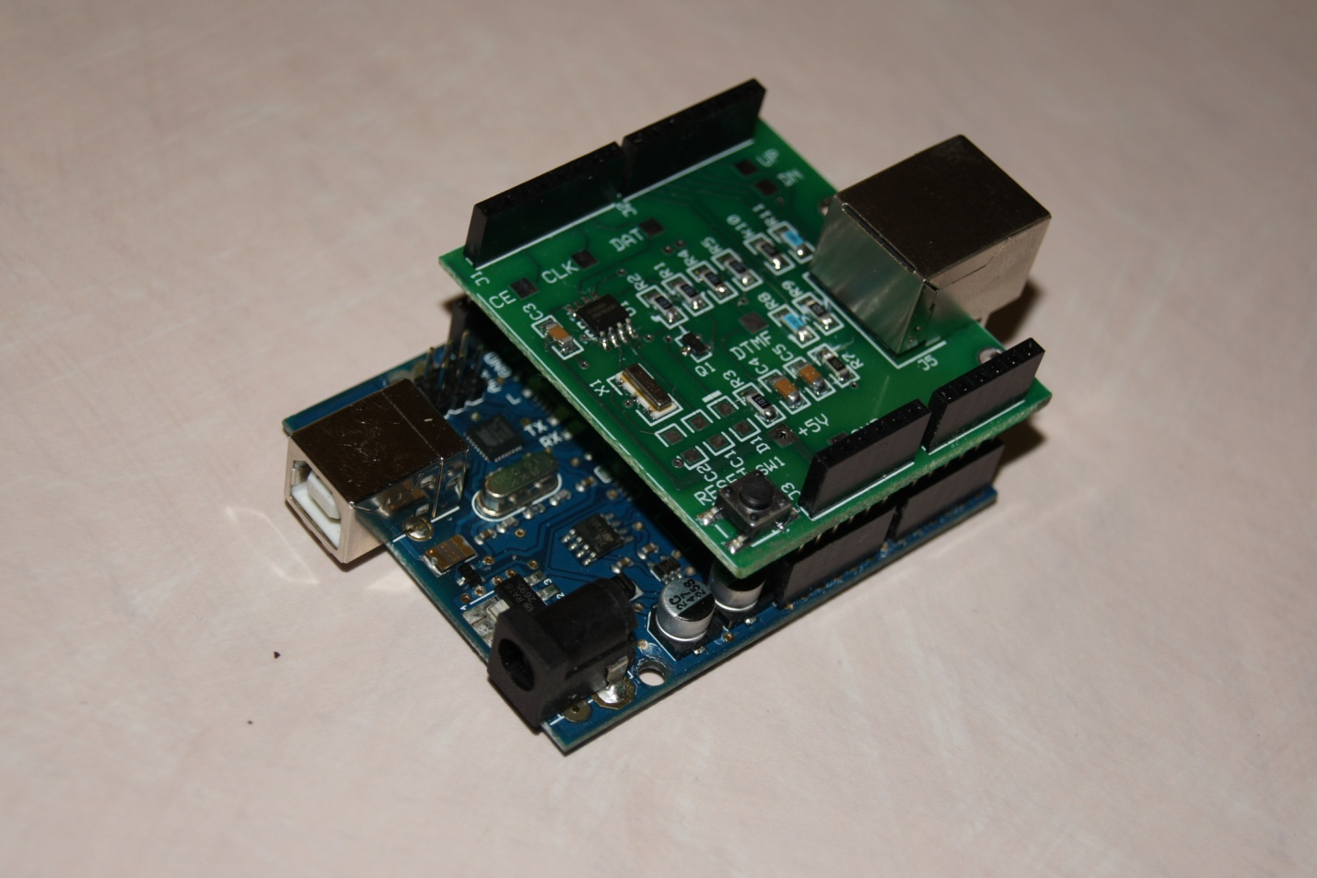

**DTMF Shield mounted on the Arduino UNO board**

You will notice there is a set of expansion connectors on the DTMF shield board, which would allow expansion to other boards, for example you could plug in another DTMF board and program 2 radios at the same time.

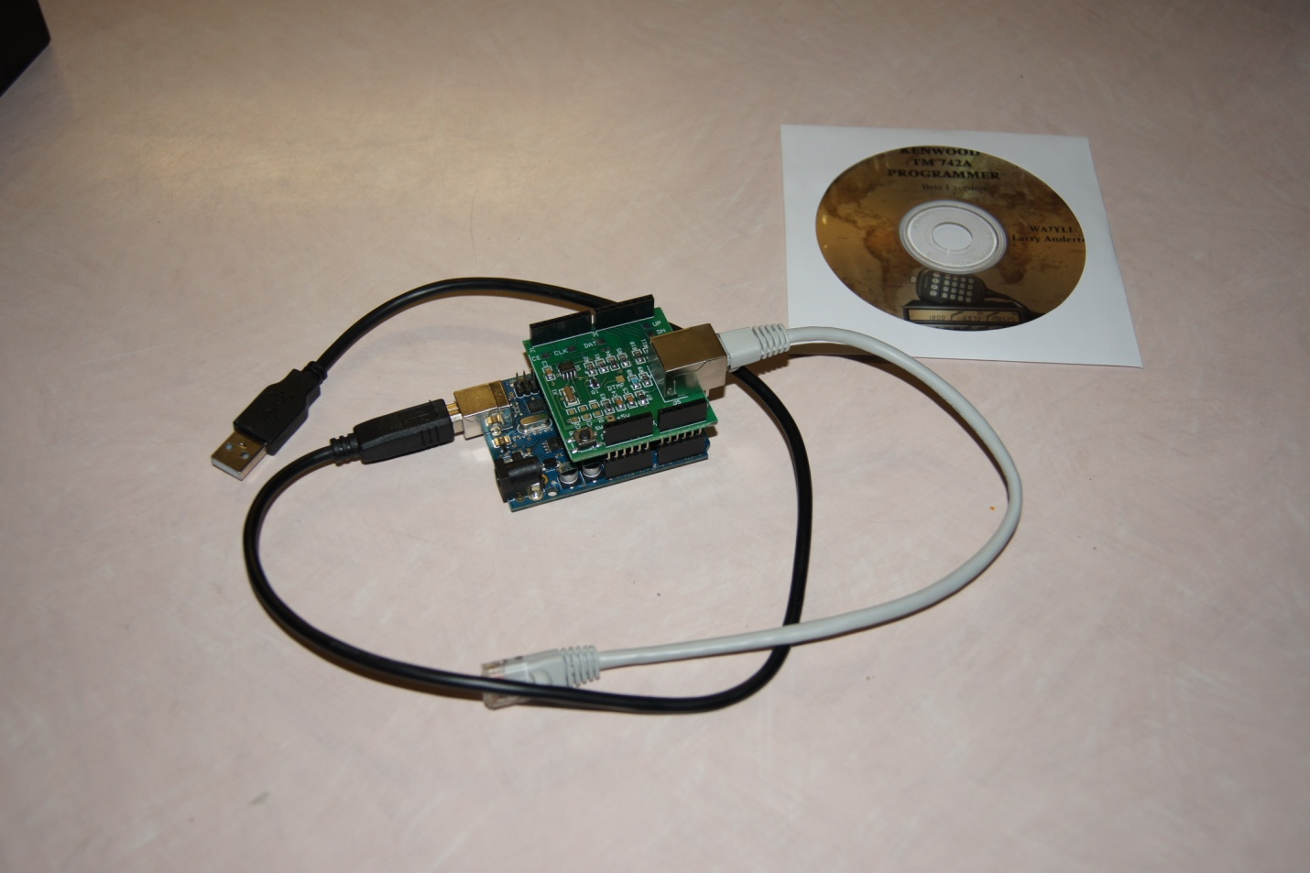

**The whole TM742 Memory Management Kit**

This is the kit as we offer it at present. We have a good prospect for an enclosure solution at present. (see next page).

It includes:

1. The Arduino Uno Microcontroller (already programmed)
2. The DTMF shield board (assembled and tested)
3. A USB interface connector for the laptop to Arduino interface
4. A short CAT5e patch cable (straight through to interface with radio microphone jack)
5. Software on CD. Setup for the programmer, Arduino design tools, drivers and Instructions.

This kit as shown is $49 (includes shipping) **(add $8 for enclosure as shown on next pages, total $57 shipped.**

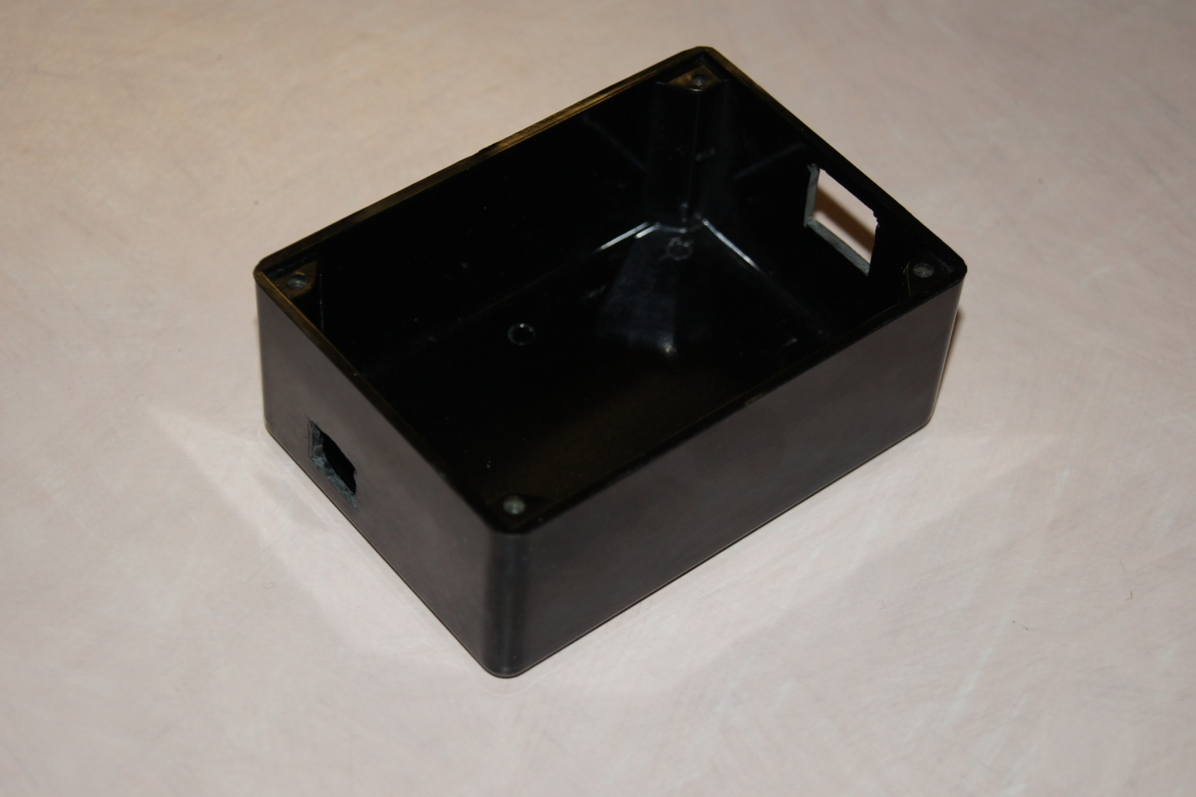

A project box that Keystone manufactures 705K-ND (Bakelite) with holes cut in for the connectors.

The cover plate is a 2042K-ND. Both are available through Digikey.

<http://www.digikey.com/product-detail/en/705/705K-ND/2918>

The holes are a bit tricky to cut, but a dremel tool with a small steel toothed cutting bit works. (after drilling a ¼ inch hole as a starter.

Hole locations shown on the next page.

I am looking into having a machine shop set up to cut 20-40 boxes if it isn’t too expensive. Please contact me around Dec 15, and I will have more info. [landerton@comcast.net](mailto:landerton@comcast.net)



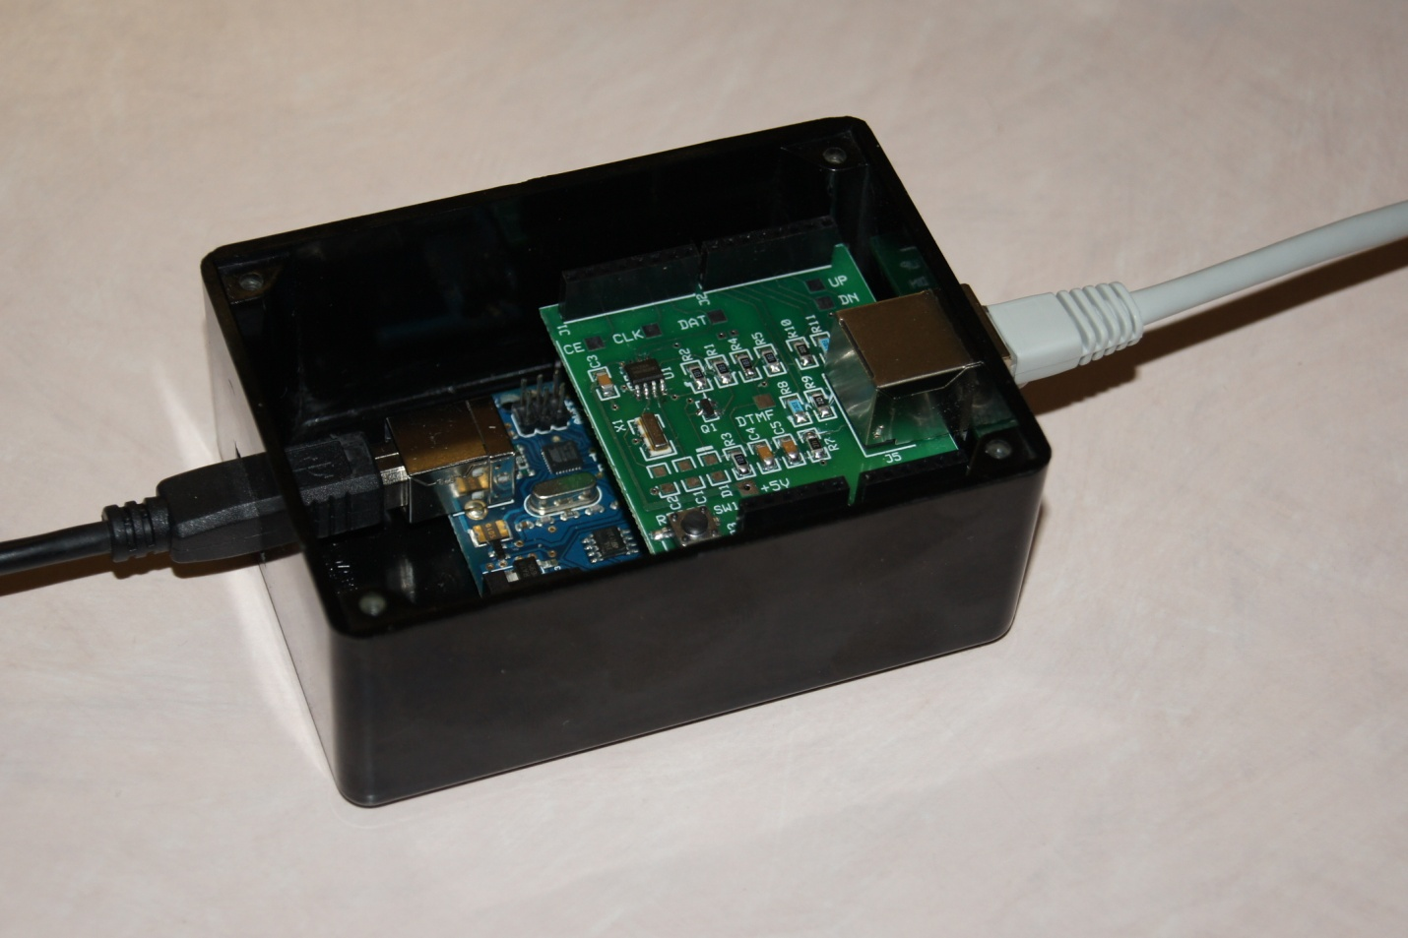

The whole TM742 Memory Management Kit installed in the Box with cables attached.

(Lid included but not shown)

